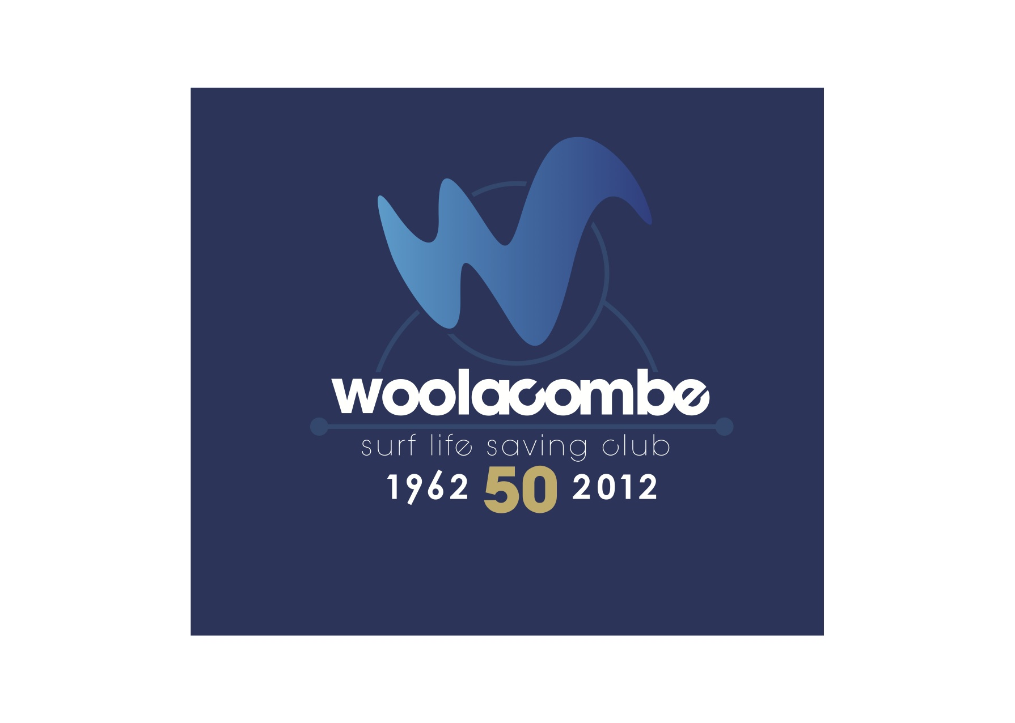

Charity Number 1176269

NORMAL OPERATING PROCEDURE

&

EMERGENCY ACTION PLAN

DURING COVID -19

AS DIRECTED BY SURF LIFE SAVING GB

(Woolacombe Beach)

2021

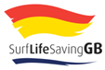
This document should be read and used in conjunction with the most current NOP and EAP for Woolacombe SLSC and current SLSGB National Safety Guide and Training Guide including Safe Bubbles.

Normal Operating Procedure

Training sessions must run in accordance with, and comply with, the latest Government Guidance and current SLSGB Approved activity plan

- Sessions will run in the open air
- Social distancing must be maintained before, during and after sessions
- No car sharing
- Activity in line with SLSGB Guidance

Competent Person

Risk Management Tool Box

1 Bubble = 10 participants and up to 15 parents/helpers

Skills Coach
L2 Coach

L1 Coach

Lifeguard

- Bubbles will have no more than 10 participants and 15 parent helpers numerous bubbles may operate at any time.
- The club hut will only be used for storage of kit.
- All personal waste e.g. tissues, first aid item and disposable PPE will be binned in disposable rubbish bag in a designated area away from general activity. These bags will then be placed in another bag and left aside for a period of 72 hours before being disposed of as normal protocols allow. 72 hours is the recommended time by Public Health England that the virus is still alive.

Decon – Bag it – Decon Hands – Re bag - Decon Again – Leave Bag 72 hrs

The Risk Assessment

- This will Drive ALL decisions for club bubbles and environment.
- All safety requirements must be in the bubble.
- Risk Assessments will be carried out prior to entering the water.
- Up to date C-19 UK government advice must be followed.
- Activity in the water will be low to help reduce the risk of any intervention.
- Sessions will continue to have a “Booking in“ system to record names, age and contact details and keep these for a minimum of 4 weeks. This is for Safeguarding and Tracing reasons.
- Details of an existing health issues will be recorded, if it is a flagged condition, they will not participate.
- Under 18’s will have to have parent/Guardian consent to participate.
- All participants will be members of SLSGB for insurance purposes.
- Coach/Lifeguard will hold a current valid lifeguard award and have a DBS check.

Pre Session Guidance each participant will

- Bring 2 bin bags for “contaminated” clothing/kit
- Bring their own minor first aid kit.
- Bring enough food and fluids.
- Arrived dressed and ready for the activity.
- Hand sanitise pre travel and on arrival.
- No car sharing.
- Bring their own equipment or pre issued club kit (no sharing).
- Only one bag per person which is to be kept in the “dirty zone” and only accessed after the session.

During the Session

- A safe area will be selected to ensure the integrity of the Bubble activity is not threatened by others on the beach.
- Non participants must NEVER enter the Bubble area
- Equipment will NOT be shared.
- If need to cough or sneeze, crouch down, do it in to the crook of your bent elbow. Tissues must be binned safely as previously stated.
- Do not share drinks.
- Stay in your Bubble.

After the Session

- Social distancing will be maintained at all times.
- Do not transfer into another bubble.
- Outer clothing will be put into bin bag/bag to take home.
- At home clothing should be washed on a hot wash.
- No car sharing.

SLSGB Guidance when no RNLI life guards are patrolling the beach during a training session.

Lifeguards will attend first aid incidents. Most of the time this will be a minor first aid incident which can be dealt with at the place of the injury. There are other times, such as weaver stings or sprains, where pre C-19, Lifeguards have taken patients and others back to their dedicated first aid room.

During C-19 the advice on risk to persons in a confined space is high and a multi-use room can increase the likelihood of transmission of the virus.

It is highly recommended to only give treatment (if safe to do so) outside and where possible, the lifeguards should distance themselves, advise the treatment needed and ask the person (or in the case of young children ask the parent/guardian) to administer treatment themselves through advice provided by the Lifeguard

Using windbreaks or barrier tape/rope to create a dedicated restricted outside area will help in the management of an outside first aid location. On busy beaches Lifeguards should create special distancing zones to manage more than one incident and to ensure members of the public do not come too close. Ensure if you have a seating area that plastic seats are decontaminated thoroughly before and after a person sits on it.

Figure 1.0

2M x 2M
2M x 2M
2M x 2M
Area 1
Clean area for 1st Aid kit
Area 2
Area 3

LG
Runner

It is extremely important that the response bags (1st aid and Pandemic response bag) do not get contaminated in anyway. The guidance is to decide if it is safe to treat, ask for a second lifeguard to act as a “runner” ( seen in figure 1.0),to collect the required item from the response bag to a location and then back away for the primary lifeguard (in PPE) to deal with the situation.

A note on the SAR Pandemic Response Bag: this bag is ONLY for Lifeguards attending an incident. It is not for personal use. It is vitally important that the equipment is logged in its use and adequate stocks are maintained. Spare equipment should be stored in a safe location where cross contamination will not happen and is managed appropriately. It is a recommendation that the bag should only have the minimum amount of kit that is required for a day’s activity and reusable items such as face shields and goggles are cleaned after every incident and checked at the end of the patrol.

Emergency Action Plan

Incidents & Rescue
A C-19 incident is when a breach of 2 metres has been made to assess/ intervene/assist a casualty, to administer first aid or to make a rescue in water.(i.e. Close physical contact) When a Patrol member(s) is involved in close physical contact they must consider themselves to be contaminated and at the earliest appropriate opportunity go back to base and undertake the decontamination procedure (outside) and don a face mask and then remove themselves from the patrol and follow guidance set by UK Government- Trace and trace (see page 2 UK Govt advise on Track and Trace))
Note from SLSGB Clinical Advisory Group,” It will not always be possible to save a life and maintain a 2-metre safe distance, or by wearing FFP2 face mask and PPE during a rescue or incident be 100% safe. It is important that individuals ensure that they (where practicable), be protected as much as possible through their personal discipline with regard to social distancing and use of PPE. The use of FFP2 face masks and other PPE during a rescue or incident will reduce the risk of contamination for rescuers and the casualty, but it will not eliminate it completely.”.
Rescue principles will follow the Search and Rescue world guidance of, “self – team – victim”. Each individual member should be fully aware of their personal situation and their families in terms of underlying health issues. The unintended consequences of personal contamination should be carefully considered before any patrol takes place, or even a rescue.
Remember that the most effective Patrol activity is prevention, 97% of the lifeguard’s role. If we aim to do this well, we reduce the likelihood of rescue. Final point, liaising with the public does not mean you have to wear PPE, just keeping 2metres away is enough.
SLSGB and this guidance follows The UK Search and Rescue Medical Committee. It sets out steps for intervention and administering first aid and CPR incidents (see later in policy).

Rescues
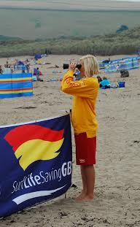
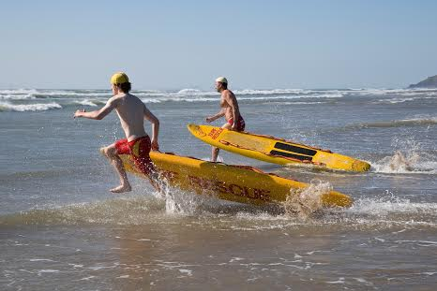
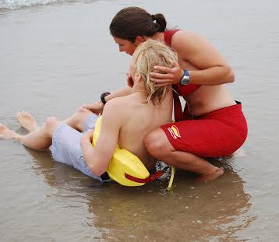
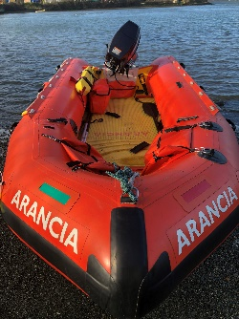
Every rescue is potentially a contact with a C-19 infected casualty. Reducing the risk should be considered. The rescue/intervention should not be at C-19 risk to the lifeguard. Where practicable try and keep a safe distance, but this may not be possible at all times.
Low Risk Exposure in Rescue Options High

In water rescue considerations
- Where practicable keep casualty at a distance
- No rescue breaths or deep water EAV
- Keep casualty facing away from you during the rescue if possible, such that they breath “away” from you.
- Bring casualty onto awaiting beach team “donned in PPE”
- Ensure protocols are met with UK SAR advice below in UKSAR Appendix 1,2 &3

Post event
- Handover casualty to emergency services in cleaned PPE
- While decontamination is taking place consider raising the red flag until team is ready
- “Clean” lifeguard should become the “decontamination officer” ensuring protocols are followed
- Equipment washed down in the doffing area as per protocols and following the sequence; Lifeguard – Rescue Board – Lifeguard
- Patrol member(s) who have had close physical contact with a casualty must consider if they are now a suspected C-19 victim and act accordingly

Appendix 1

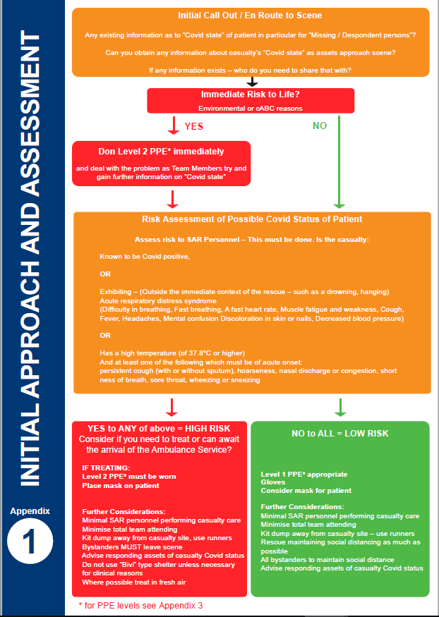
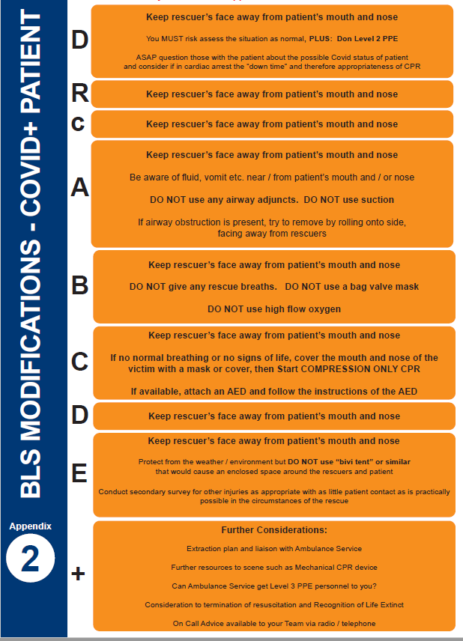
Appendix 2
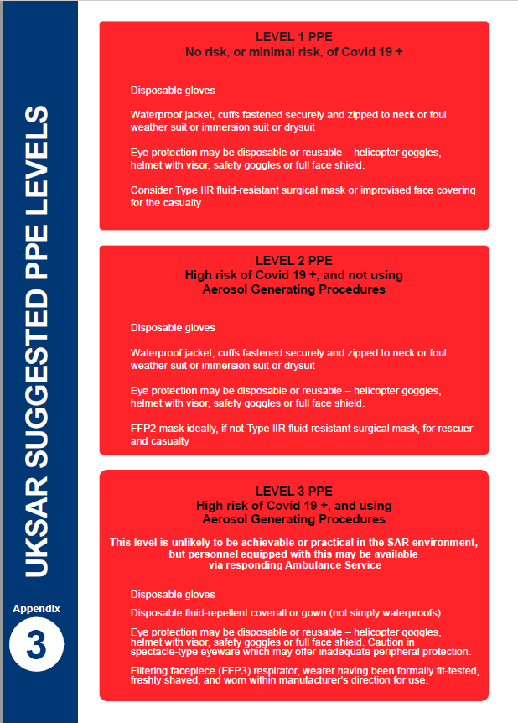
Appendix 3
NOT APPLICABLE TO SLSGB EAP

